### **Ancient Knot**

As a math teacher, I am always looking for something interesting for my students to do in class. I came across the following resource.   
<http://www.math.nmsu.edu/breakingaway/Lessons/ancientknot1/ancientknot.html>I am intrigued by this ancient knot and I am happy to find this design has roots in mathematics. I used their instructions and created the following ancient knot.

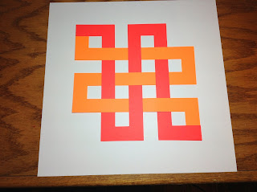

Ancient Knot Design on a 12 x 12 piece of paper

I have seen this same design at the Textile Museum in Washington, DC in Kuba textiles at the Woven Art of Central Africa exhibit in 2011. The Africans used different color plant materials to create their designs. The plant material was worked to the point that the fibers softened and they were amazingly able to create velvet.   
  
I think this design would look beautiful in a quilt because as the math blog says,  
  
 "It has no beginning or end, and according to folklore, it represents longevity and immortality."  
  
What a beautiful thing to put into a quilt which is a labor of love. You could use the Silhouette fabric blade to cut out all of the pieces which would simplify cutting the intricate pieces.